Basic Facts on Hearing Loss

Statistics
- About 20 percent of Americans, 48 million, report some degree of hearing loss.
- At age 65, one out of three people has a hearing loss.
- 60 percent of the people with hearing loss are either in the work force or in educational settings.
- While people in the workplace with the mildest hearing losses show little or no drop in income compared to their normal hearing peers, as the hearing loss increases, so does the reduction in compensation.
- About 2-3 of every 1,000 children in the United States are born with a detectable hearing loss in one or both ears.
- Almost 15% of school-age children (ages 6-19) have some degree of hearing loss.
For more information, go to the Hearing Loss of America website at www.hearingloss.org or to the United Methodist Committee on Deaf and Hard of Hearing Ministries website at www.umdeaf.org.
Statistics sources: Johns Hopkins Medicine
Other sources: National Information Center on Deafness and Other Communication Disorders, National Institutes of Health, National Council on Aging, Centers for Disease Control and Prevention (CDC), and the MarkeTrak VIII Study by Sergei Kochkin, Ph.D.

Basic Facts on Hearing Loss

Statistics
- About 20 percent of Americans, 48 million, report some degree of hearing loss.
- At age 65, one out of three people has a hearing loss.
- 60 percent of the people with hearing loss are either in the work force or in educational settings.
- While people in the workplace with the mildest hearing losses show little or no drop in income compared to their normal hearing peers, as the hearing loss increases, so does the reduction in compensation.
- About 2-3 of every 1,000 children in the United States are born with a detectable hearing loss in one or both ears.
- Almost 15% of school-age children (ages 6-19) have some degree of hearing loss.
For more information, go to the Hearing Loss of America website at www.hearingloss.org or to the United Methodist Committee on Deaf and Hard of Hearing Ministries’ website at www.umdeaf.org.
Statistics sources: Johns Hopkins Medicine
Other sources: National Information Center on Deafness and Other Communication Disorders, National Institutes of Health, National Council on Aging, Centers for Disease Control and Prevention (CDC), and the MarkeTrak VIII Study by Sergei Kochkin, Ph.D.

AMERICAN SIGN LANGUAGE
American Sign Language (ASL) is the preferred language for the Deaf community, those who are Deaf, hard of hearing, and Deafblind. When one sees a capital ‘D’ in the word Deaf, it indicates cultural deafness within what is discussed or stated. Besides indicating hearing loss, the lower-case “d” indicates someone who is not culturally deaf. Most Deaf people DO NOT read lips. Learning the manual alphabet can help bridge the communication, at least in a small way.
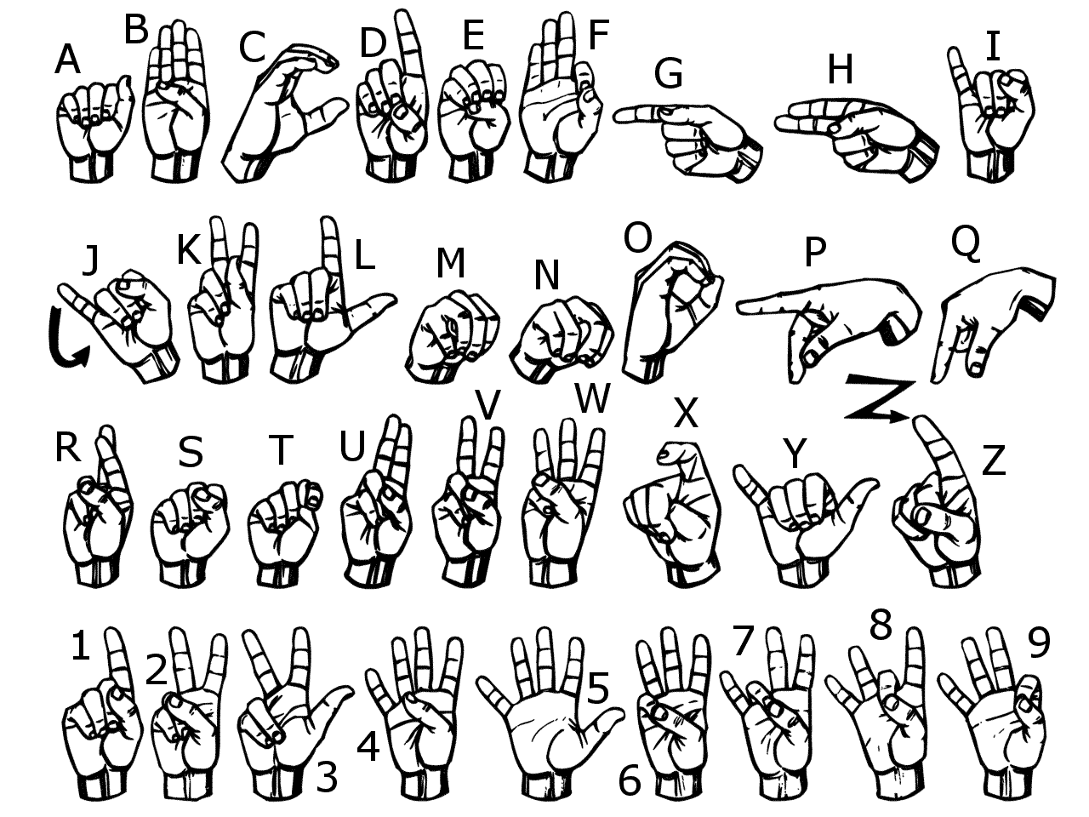
For more information, go to the United Methodist Committee on Deaf and Hard of Hearing Ministries website at www.umdeaf.org.
AMERICAN SIGN LANGUAGE
American Sign Language (ASL) is the preferred language for the Deaf community, those who are Deaf, hard of hearing, and Deafblind. When one sees a capital ‘D’ in the word Deaf, it indicates cultural deafness within what is discussed or stated. Besides indicating hearing loss, the lower-case “d” indicates someone who is not culturally deaf. Most Deaf people DO NOT read lips. Learning the manual alphabet can help bridge the communication, at least in a small way.
For more information, go to the United Methodist Committee on Deaf and Hard of Hearing Ministries website at www.umdeaf.org.
Types of Hearing Loss
When it comes to hearing loss, there are various types. The most common are listed below.
* Conductive hearing loss - when hearing loss is due to problems with the ear canal, ear drum, or middle ear and its little bones (the malleus, incus, and stapes).
* Sensorineural hearing loss (SNHL) - when hearing loss is due to problems of the inner ear, also known as nerve-related hearing loss.
* Mixed hearing loss - refers to a combination of conductive and sensorineural hearing loss. This means that there may be damage in the outer or middle ear and in the inner ear (cochlea) or auditory nerve.
Some Causes
Conductive Hearing Loss Sensorineural Hearing Loss
* Malformation of outer ear, * Exposure to loud noise
ear canal, or middle ear
* Fluid from colds * Head or trauma
* Ear infection * Virus or disease
* Allergies * Hereditary
* Poor Eustachian tube function * Aging
* Perforated eardrum * Malformation of the inner
ear
* Benign tumors * Meniere’s disease
* Impacted earwax * Otosclerosis
* Infection in the ear canal * Tumors
Source: Hearing Loss of America website at www.hearingloss.org. For more information, go to the United Methodist Committee on Deaf and Hard of Hearing Ministries’ website at www.umdeaf.org.
Types of Hearing Loss
When it comes to hearing loss, there are various types. The most common are listed below.
* Conductive hearing loss - when hearing loss is due to problems with the ear canal, ear drum, or middle ear and its little bones (the malleus, incus, and stapes).
* Sensorineural hearing loss (SNHL) - when hearing loss is due to problems of the inner ear, also known as nerve-related hearing loss.
* Mixed hearing loss - refers to a combination of conductive and sensorineural hearing loss. This means that there may be damage in the outer or middle ear and in the inner ear (cochlea) or auditory nerve.
Some Causes
Conductive Hearing Loss Sensorineural Hearing Loss
* Malformation of outer ear, * Exposure to loud noise
ear canal, or middle ear
* Fluid from colds * Head or trauma
* Ear infection * Virus or disease
* Allergies * Hereditary
* Poor Eustachian tube function * Aging
* Perforated eardrum * Malformation of the inner
ear
* Benign tumors * Meniere’s disease
* Impacted earwax * Otosclerosis
* Infection in the ear canal * Tumors
Source: Hearing Loss of America website at www.hearingloss.org. For more information, go to the United Methodist Committee on Deaf and Hard of Hearing Ministries’ website at www.umdeaf.org.
SYMPTOMS OF HEARING LOSS
If you or someone else suspects hearing loss, you’re not alone. On average, it takes people seven years from the time they think they might have a hearing loss before seeking treatment.
How can I tell if I have hearing loss?
If you answer yes to some of the following questions, you may have a hearing loss
* Often ask people to repeat what they say?
* Have trouble hearing in groups?
* Think others mumble?
* Fail to hear someone talking from behind you?
* Turn up the volume on the TV or car radio?
* Have difficulty on the phone?
* Have trouble hearing your alarm clock?
* Have difficulty hearing at the movies?
* Dread going to noisy parties and restaurants?
Think about these situations
* Are you embarrassed to talk openly about not being able to hear?
* Are you cutting out activities that you used to love but have become painful because you cannot join in fully anymore?
* At work are you afraid to reveal your hearing loss in case it jeopardizes your job and your supervisor and coworkers may see you as less competent?
* Are you bluffing when out with friends in noisy restaurants?
* Are you feeling cut off from your young children because you cannot hear their high-pitched voices?
* Are family holidays a strain because so many people are talking at once?
These are common reactions and can lead to withdrawal from social interaction, anxiety, loss of self-esteem and even depression.
Source: Hearing Loss of America website at www.hearingloss.org. For more information, go to the United Methodist Committee on Deaf and Hard of Hearing Ministries’ website at www.umdeaf.org.
SYMPTOMS OF HEARING LOSS
If you or someone else suspects hearing loss, you’re not alone. On average, it takes people seven years from the time they think they might have a hearing loss before seeking treatment.
How can I tell if I have hearing loss?
If you answer yes to some of the following questions, you may have a hearing loss
* Often ask people to repeat what they say?
* Have trouble hearing in groups?
* Think others mumble?
* Fail to hear someone talking from behind you?
* Turn up the volume on the TV or car radio?
* Have difficulty on the phone?
* Have trouble hearing your alarm clock?
* Have difficulty hearing at the movies?
* Dread going to noisy parties and restaurants?
Think about these situations
* Are you embarrassed to talk openly about not being able to hear?
* Are you cutting out activities that you used to love but have become painful because you cannot join in fully anymore?
* At work are you afraid to reveal your hearing loss in case it jeopardizes your job and your supervisor and coworkers may see you as less competent?
* Are you bluffing when out with friends in noisy restaurants?
* Are you feeling cut off from your young children because you cannot hear their high-pitched voices?
* Are family holidays a strain because so many people are talking at once?
These are common reactions and can lead to withdrawal from social interaction, anxiety, loss of self-esteem and even depression.
Source: Hearing Loss of America website at www.hearingloss.org. For more information, go to the United Methodist Committee on Deaf and Hard of Hearing Ministries’ website at www.umdeaf.org.
Communication Tips with Hearing Loss
Communication is a two-way street. Here are tips for the person who hears well, and for the person with hearing loss:
Tips for Hearing Person
Set Your Stage
* Face person directly.
* Spotlight your face (no backlighting).
* Avoid noisy backgrounds.
* Get attention first.
* Ask how you can facilitate communication.
* When audio and acoustics are poor, emphasize the visual.
Get the Point Across
* Don't shout.
* Speak clearly, at moderate pace, not over-emphasizing
words.
* Don't hide your mouth, chew food, gum, or smoke while
talking.
* Re-phrase if you are not understood.
Tips for the Person with Hearing Loss
Set Your Stage
* Tell others how best to talk to you.
* Pick your best spot (light, quiet area, close to speaker).
* Anticipate difficult situations, plan how to minimize them.
Do Your Part
* Pay attention.
* Concentrate on speaker.
* Look for visual clues.
* Ask for written cues if needed.
Source: Hearing Loss of America website at www.hearingloss.org. For more information, go to the United Methodist Committee on Deaf and Hard of Hearing Ministries’ website at www.umdeaf.org.
Communication Tips with Hearing Loss
Communication is a two-way street. Here are tips for the person who hears well, and for the person with hearing loss:
Tips for Hearing Person
Set Your Stage
* Face person directly.
* Spotlight your face (no backlighting).
* Avoid noisy backgrounds.
* Get attention first.
* Ask how you can facilitate communication.
* When audio and acoustics are poor, emphasize the visual.
Get the Point Across
* Don't shout.
* Speak clearly, at moderate pace, not over-emphasizing
words.
* Don't hide your mouth, chew food, gum, or smoke while
talking.
* Re-phrase if you are not understood.
Tips for the Person with Hearing Loss
Set Your Stage
* Tell others how best to talk to you.
* Pick your best spot (light, quiet area, close to speaker).
* Anticipate difficult situations, plan how to minimize them.
Do Your Part
* Pay attention.
* Concentrate on speaker.
* Look for visual clues.
* Ask for written cues if needed.
Source: Hearing Loss of America website at www.hearingloss.org. For more information, go to the United Methodist Committee on Deaf and Hard of Hearing Ministries’ website at www.umdeaf.org.

