A BRIEF GUIDE TO ASSISTIVE LISTENING DEVICES OR SYSTEMS

Assistive Listening Devices or Systems are available for hard of hearing people whose losses vary from moderate to severe. Churches install them to make their worship services, Sunday School, meetings, etc., accessible. The device or system is designed so that the sound of voice and music is transmitted directly to hearing aid users free of background noise, echoes, and distortions of speech. Otherwise, without it, sound waves bounce against the walls far and near before they reach the ears, thus the results are often distorted with background noise.
There are three general kinds of assisted listening systems:
1. Audio loop
2. Infrared system
3. FM system.
Each system requires a transmitter which is then connected to a sound system if a church has it.
Audio Loop System
For the audio loop system, the electromagnetic wire (under the carpet or taped to floor) circles the room or part of it. Any person with a hearing aid or cochlear implant who turns on the telecoil switch can hear the sound that is transmitted from the loop.
Infrared System and FM System
These two systems require the use of wireless personal receivers. They come with neck loop, behind-the-ear silhouette inductor, or ear buds. Ear buds are for those who don’t wear hearing aids. The telecoils of hearing aids or cochlear implants pick up the sounds via neck loop and behind-the-ear silhouette inductor. The infrared system works through invisible light beams while the FM systems is done through radio waves.
Other
For Sunday school and small meetings, personal FM system is available. The system is usually a pocket transmitter with a microphone and a personal receiver with a neck loop. A conference table microphone can be plugged into the transmitter. Kits are available with personal receivers, or more for a group.
AUDIO LOOP SYSTEM FM SYSTEM
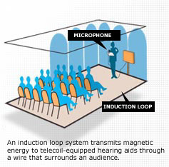 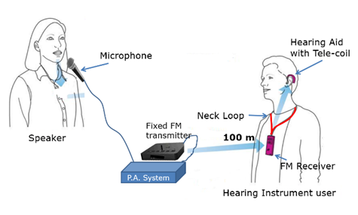

INFRARED SYSTEM
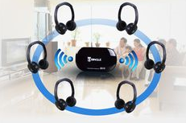

Amplicon:
www.amplicomusa.com/
Outstanding customer service, the latest technology and a dedication to excellence make Amplicom the leader in amplified telephones. So choose the best, and hear every conversation loud and clear!
Audex, Inc.:
http://www.audex.com/
The company has evolved into one of the most innovative and respected providers of infrared, magnetic induction listening devices and telephones for hearing impaired people in the United States.
Bellman & Symfon AB:
www.bellman.com
A wide range of hearing products including: Fire safety solutions, Home alerting solutions, Listening systems for doorbells and telephones, Personal amplifiers
Harris Communications:
www.harriscomm.com
Products include the following: Assistive listening devices, Emergency alarms, Hearing aid accessories, Hearing protection, Loop systems, Personal amplifiers, Telephones
ClearSounds:
www.clearsounds.com/
Welcome to ClearSounds, a passionate, women-owned, family company with 30+ years dedicated to advanced sound technology. We specialize in powerful amplified phones, Bluetooth headsets, amplified neckloops, mobile accessories and listening systems for people with hearing loss and those looking for a remarkable listening experience. ClearSounds is the leading developer of highly advanced devices for the hearing impaired for the home, the office, and on the road. We create, design, produce, and manufacture all of our own products. Our commitment to having Massive Positive Impact continues beyond the sale of a product. We believe in the Golden Rule and that respect, kindness, care and support are not marketing tools - it is simply the only acceptable way to treat a customer.
GeeMarc:
www.geemarc.com
With 5 decades of experience designing and manufacturing Telecommunications Equipment Geemarc Telecom is the natural choice for your Specialized communication Equipment. The Geemarc Clearsound range of Assistive Listening Devices now has over 80 products and is the largest variety of Assistive Products available today under one roof.
Krown Manufacturing:
www.krownmfg.com
Krown Manufacturing, Inc. and Compu-TTY, Inc. carry a wide variety of hearing impaired products including: Alarm clocks, Amplified telephone, Telephone signaler, TTY devices, Wireless emergency alerting devices.
Phonic Ear
www.phonicear.com
Phonic Ear is a Danish-owned company that is part of William Demant Holding A/S (WDH) and has over 100 years’ experience in the hearing and sound business. The WDH concern consists of a number of internationally focused companies, including Oticon A/S – one of the world leaders in the hearing aid business. Assistive listening devices and assistive listening systems.
Serene Innovations, Inc.:
www.sereneinnovations.com
Products include the following: Alerting notification systems, Amplified phones, Clocks & watches, Hearing aid care, Landline amplifier, Personal amplifier, Ringer / Flasher and TV listening.
SilentCall Communications:
www.silentcall.com
Visual & Tactile Alerts for people who are Deaf and Hard of Hearing: Alerting systems for people who are deaf and hard of hearing, Alerting systems for seniors, Deaf blind alerting devices, Deaf products, Hard of hearing products, Smoke detectors for the deaf / hard of hearing, Weather alerting devices for people who are deaf and hard of hearing.
Sonic Alert:
http://www.sonicalert.com
Specialized hearing solutions for the hard of hearing: Alarm clocks, Amplified phones, Listening devices, Signaling devices.
Ultratec:
http://www.ultratec.com
Ultratec has been working to make telephone access more convenient and reliable for people with hearing loss. Today, our equipment is recognized worldwide as the standard for excellence in text telecommunications. Telephones that display captions of everything the caller is saying. Text telephones, simplicity signalers and amplified phones.

