**United Methodist Committee on   
Deaf and Hard of Hearing   
Ministries Committee**  
Contact the committee to learn more and for more information. Also, enroll to receive our quarterly newsletter. The newsletter includes resources, best practices, national and local Deaf ministry news, and other information.  
www.umdeaf.org

“To share Jesus’ love by equipping and advocating access through effective communication and leadership among the diverse  
Deaf communities.”

**UNITED METHODIST COMMITTEE ON DEAF AND HARD OF HEARING MINISTRIES**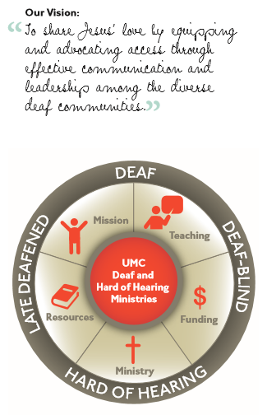

Check out our sister committee,   
Disability Ministries Committee   
of The United Methodist Church www.umcdmc.org  
decorative border  
 **Additional Resources**

For additional congregational resources, visit the United Methodist Congress of the Deaf’s website  
at www.umdeaf.org.

A helpful resource is *Deaf Ministry: Ministry Models for Expanding the Kingdom of God, 4th Ed* by Leo Yates, Jr. It can be purchased at Amazon.com.

**Guidance for Hospitality and a Deaf-Friendly Worship**



**United Methodist Committee on Deaf and Hard of Hearing Ministries**

**Global Ministries**  
The United Methodist Church

**General Board of Global Ministries**

**The United Methodist Church**

**458 Ponce De Leone Ave NE**     
**Atlanta, GA 30308**

**www.umcmission.org**

**United Methodist Committee on Deaf and Hard of Hearing Ministries**  
www.umdeaf.org

**United Methodist Association of   
Ministers with Disabilities**  
https://amdumc.wordpress.com/

**Disability Ministries Committee  
of The** **United Methodist Church**  
www.umcdmc.org

**The United Methodist   
Congress of the Deaf**  
www.umcd.org

**How to Support the Committee  
Give to the Advance:**By Check:  
Make payable to “Advance GCFA.” Be sure to write Advance #982562 and “Deaf and Hard of Hearing Ministries” on the check. Send Checks to   
The Advance  
458 Ponce De Leon Ave, NE  
Atlanta, GA 30308  
  
By Credit Card:  
Call 1-888-252-6174 or go to www.umcmission.org/Give and search for Advance #982562.

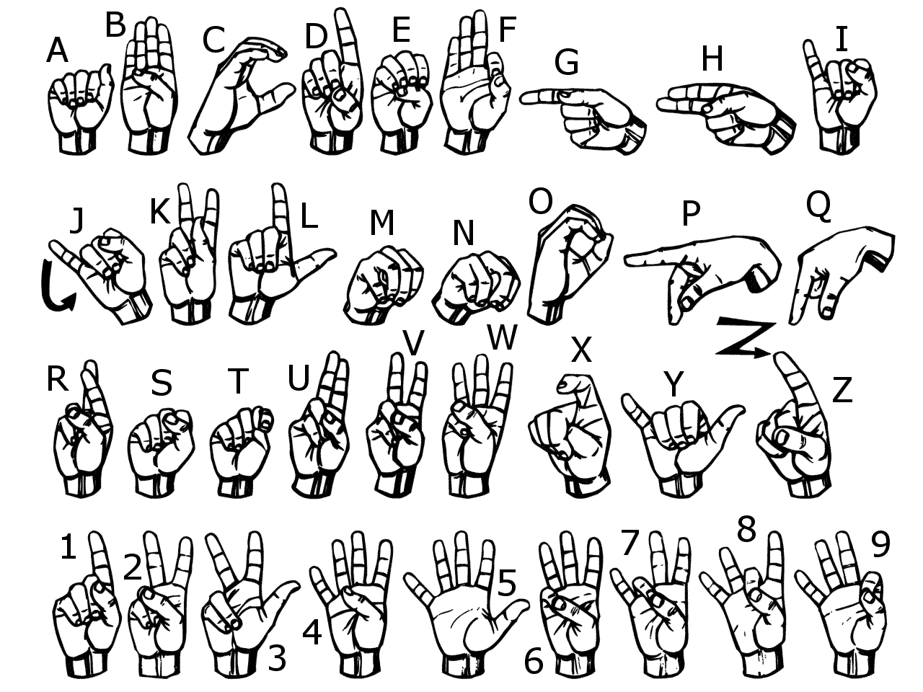

**The United Methodist Committee on   
Deaf and Hard of Hearing Ministries** is a Global Ministries committee. The committee provides resources, consultation, cultivates Deaf ministries, educates congregations, helps to develop Deaf leaders, and offers grants to United Methodist churches. Helpful to know is when reading a capital ‘D’ in the word deaf, it indicates cultural deafness within what is discussed or stated. Besides indicating hearing loss, the small ‘d’ in deaf indicates someone who is not culturally Deaf.

**Hospitality**

Hospitality is a key function for welcoming Deaf, hard of hearing, late-deafened, and Deaf-blind persons and their families. It is also essential for growing a Deaf ministry and for being Christ to one another. It’s not just for guests, but it’s for everyone and should be consistent. Hospitality is about conveying the sense of welcome to a friend and the stranger alike. Included is having a mindset and an attitude that draws people in and makes them feel apart even if only a visitor. Each church has their own way of showing hospitality that is inviting and welcoming. Some churches even offer knickknacks to visitors. Essentially, a Deaf ministry should be about making relationships. Have a contact person for accommodation requests. Several points to keep in mind are:

1. Begin with your church website & social media. This is often a starting point for people to consider visiting your church. Promote your ministry on the website.
2. Always welcome new people. Approach them and tell them you’re glad to meet them or see them again.
3. Insert in the church bulletin a few ways your church is accessible (e.g., Have assisted listening device, accessible bathrooms, dry erase boards around the church to communicate, large print bulletins being available, and so on.).
4. Show interest in them. Do more of the listening. Be genuine about this, as Deaf people pick up on body language.
5. Have worship leaders know a little bit of sign language. From the pulpit, signing, “good morning” or “welcome” goes a long way.
6. Offer fellowship opportunities, which may include the need to have the interpreter stay beyond the worship service. Refreshments are often useful in having people stay after the service.

Check out www.umdeaf.org (under resources) for more suggestions.

**Deaf-Friendly Worship Service**

For hearing churches who wish to adapt their worship service and make it more Deaf-friendly, consider these recommendations.

1. If you have an interpreter, be sure to promote it on the church website & social media.
2. Try not to dim the lights all the way as Deaf, hard of hearing, late-deafened, and Deaf-blind people still need visual access.
3. Learn some church-related signs and phrases and use them during worship (e.g., opening prayer or the benediction).
4. Teach greeters, ushers, and even the pastor to sign "good morning" to both Deaf and hearing people. This raises awareness.
5. Have a children’s choir or a youth choir sign a hymn or a song, whether the whole hymn/song or a stanza or two. Certainly, the adult choir can offer this as well, either a few members or the whole choir.
6. Include a short Christian or biblical drama, as it’s visual. Perhaps act out a scene from a Scripture passage or the entire passage while you have a narrator to sign the Scripture. Verses do not necessarily have to be signed by the actors, as long as their gesturing and acting are clear.
7. Use more visuals throughout the service, such as multimedia and liturgical dancing. UMC sponsored ASL videos can be located at www.umc.org/what-we-believe/glossary.
8. Use a sound system with a microphone (be consistent). Offer an assisted listening device or system. Be sure ushers know where the devices are located (grants are available for these).
9. Be sure to have a few large-print bulletins and inserts) on hand for any Deaf-blind individuals (some persons may be partially-blind).
10. Some Deaf and hard of hearing people like reserved seats near the pulpit and/or near the interpreter, while others do not feel it’s necessary. Ask them for their preference.
11. Offer captioning (such as otter.ai or Microsoft products), whether in the sanctuary, live-stream services, and/or for online meetings.
12. If offering virtual services or meetings via Zoom, turn on the captioning feature.  
      
    