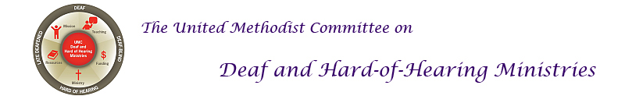
Communication Tips with Hearing Loss
Communication is a two-way street. Here are tips for the person who hears well, and for the person with hearing loss:
Tips for Hearing Person
Set Your Stage
* Face person directly.
* Spotlight your face (no backlighting).
* Avoid noisy backgrounds.
* Get attention first.
* Ask how you can facilitate communication.
* When audio and acoustics are poor, emphasize the visual.
Get the Point Across
* Don't shout.
* Speak clearly, at moderate pace, not over-emphasizing
words.
* Don't hide your mouth, chew food, gum, or smoke while
talking.
* Re-phrase if you are not understood.
Tips for the Person with Hearing Loss
Set Your Stage
* Tell others how best to talk to you.
* Pick your best spot (light, quiet area, close to speaker).
* Anticipate difficult situations, plan how to minimize them.
Do Your Part
* Pay attention.
* Concentrate on speaker.
* Look for visual clues.
* Ask for written cues if needed.
Source: Hearing Loss of America website at www.hearingloss.org. For more information, go to the United Methodist Committee on Deaf and Hard of Hearing Ministries’ website at www.umdeaf.org.
Communication Tips with Hearing Loss
Communication is a two-way street. Here are tips for the person who hears well, and for the person with hearing loss:
Tips for Hearing Person
Set Your Stage
* Face person directly.
* Spotlight your face (no backlighting).
* Avoid noisy backgrounds.
* Get attention first.
* Ask how you can facilitate communication.
* When audio and acoustics are poor, emphasize the visual.
Get the Point Across
* Don't shout.
* Speak clearly, at moderate pace, not over-emphasizing
words.
* Don't hide your mouth, chew food, gum, or smoke while
talking.
* Re-phrase if you are not understood.
Tips for the Person with Hearing Loss
Set Your Stage
* Tell others how best to talk to you.
* Pick your best spot (light, quiet area, close to speaker).
* Anticipate difficult situations, plan how to minimize them.
Do Your Part
* Pay attention.
* Concentrate on speaker.
* Look for visual clues.
* Ask for written cues if needed.
Source: Hearing Loss of America website at www.hearingloss.org. For more information, go to the United Methodist Committee on Deaf and Hard of Hearing Ministries’ website at www.umdeaf.org.

