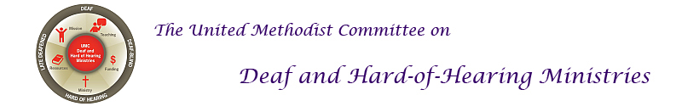
Introduction to Sign Language
American Sign Language (ASL) is the preferred language for the Deaf community. Like spoken languages, sign language is not universal, but is often distinguished by country and even has nuances by region or area. It is an expressive, beautifully complex language that includes visual, gestural, and spatial components. Below are a few signs to learn and get you started.
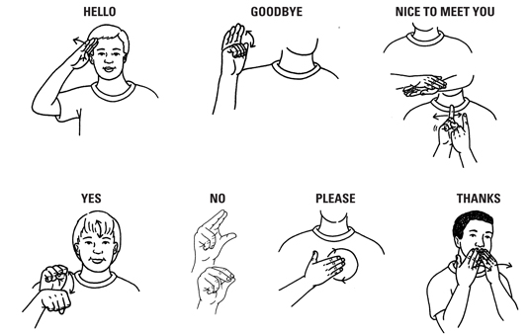
Want to learn more, check out Start ASL [www.startasl.com].
Source: https://thesharespace.wordpress.com/2013/03/14/sign-with-me-quick-and-easy-signs/
For more information, go to the United Methodist Committee on Deaf and Hard of Hearing Ministries’ website at www.umdeaf.org.

Introduction to Sign Language

American Sign Language (ASL) is the preferred language for the Deaf community. Like spoken languages, sign language is not universal, but is often distinguished by country and even has nuances by region or area. It is an expressive, beautifully complex language that includes visual, gestural, and spatial components. Below are a few signs to learn and get you started.
Want to learn more, check out Start ASL [www.startasl.com].
Source: https://thesharespace.wordpress.com/2013/03/14/sign-with-me-quick-and-easy-signs/
For more information, go to the United Methodist Committee on Deaf and Hard of Hearing Ministries’ website at www.umdeaf.org.

