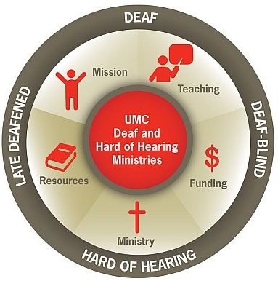
United Methodist Committee on
Deaf & Hard of Hearing
Ministries
Spring 2019 Newsletter

DEAF UNITED METHODISTS GATHER IN THE SEJ
Deaf United Methodists gathered in the Southeastern Jurisdiction on March 22-23, 2019 in North Georgia. The leadership retreat compromised of Deaf, hard of hearing, Deafblind, and hearing allies who were associated with the United Methodist Congress of the Deaf (UMCD), a national caucus, met at the Epworth by the Sea. Epworth was the location where John and Charles Wesley served as missionaries in the early Methodist movement. The Deaf and Hard of Hearing Ministries Committee supported the retreat, which was financially supported by Global Ministries. Mary Harris and Rev. Leo Yates, Jr. coordinated the retreat. Mary Deters, the president of the SEJ, expressed her gratitude for hosting the event. On the last day of the retreat, the SEJ of the UMCD held a business meeting and elected new officers. They were Mary Deters (president), Esther Choi (vice president), Richard Stallworth (treasurer), Mary Harris (secretary), and Betty Ostrom (spiritual advisor).

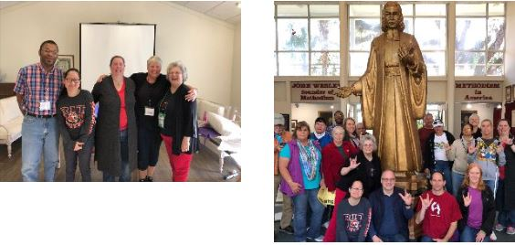
Image Description: Image Description:
5 persons representing SEJ Group with John Wesley board statue

DEAF MINISTRY BEST PRACTICES

This quarter's Deaf Ministry best practice is including hearing allies in Deaf Ministries. Hearing allies, which are sometimes hearing family members of Deaf and hard of hearing people and sign language interpreters, have often supported Deaf ministries with their presence, finances, resources, and advocacy. Many hearing allies know little to some sign language, while others are fluent in sign language.

Image Description: Wheels with BEST PRACTICE written out

ADVOCACY SPOTLIGHT

May is Better Hearing and Speech Month. It's an opportunity for Deaf Ministries and churches to raise awareness around hearing loss and shine a spotlight on communication access. The Deaf & Hard of Hearing Ministries Committee offers resources. Check out their resource page for guides, brochures, and bulletin inserts. A few suggestions for how to raise awareness in May include:
* Bulletin inserts about hearing loss (see the resource page link)
* Write a brief article for your church newsletter highlighting hearing loss among seniors (or request
permission to reprint an article from Hearing Life magazine)
* Announce signs of noise and hearing loss prevention each Sunday during May
* Encourage self-test hearing screenings (click here to find an audiologist)
* Offer a sign language class (here's a list of online classes)
* Share a flyer of any related events with audiology offices and hearing aid centers
* Host a Deaf Awareness Sunday or a Deaf Ministry Sunday (here's an online guide)

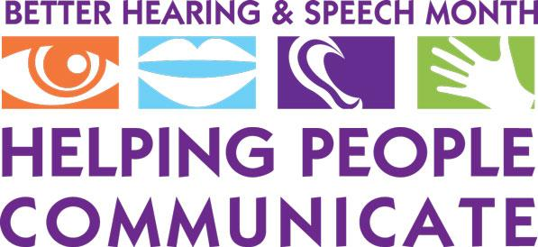
Image Description: BETTER HEARING & SPEECH MONTH AD

DEAF OBSERVERS ATTEND GC
There were two Deaf and hard of hearing observers who attended the Special General Conference in St. Louis, MO, which was held in February 2019. Global Ministries supported their travel and accommodations. The Rev. Dr. Tom Hudspeth (representing the Deaf & Hard of Hearing Ministries Committee) and Billy Deters (president of the United Methodist Congress of the Deaf) attended the conference to provide Deaf representation. Both provided daily posts through social media and also shared concerns with the General Conference coordinator for how to improve communication access. Other Deaf & Hard of Hearing Ministries committee members were also present, which were Mary Harris, Michelle Menefee, and Rev. Leo Yates, Jr.

AVAILABLE GRANTS $ $ $
The United Methodist Committee on Deaf and Hard of Hearing Ministries has grants available for up to $5,000.00. The grant cycles for 2019 are June and November. Grant applications are found on the committee's website. Previous grants awarded before include supporting Deaf/Deaf-blind camps, implementing a Deaf seniors program, a new interpreting ministry with outreach, and the installation of assisted listening systems that included sign language classes. Grants being awarded this year are to be dynamic and show completion by the end of 2019. Having recruited a sign language interpreter for the interpreting ministry, actively promoting the interpreting ministry, and the installation of a new assisted listening system are examples of a new or expanding ministry project that a grant might likely be awarded. Rev. Leo Yates, the committee's consultant, is available for assistance. His email is leoyjr@gmail.com.

DEAF MINISTRY SPOTLIGHT
A few Deaf Ministries that stands out in this quarter's newsletter are St. John UMC in Anchorage, AL, the Deaf & Mute Ministry in the Philippines, and St. Paul UMC in Odessa, DE.

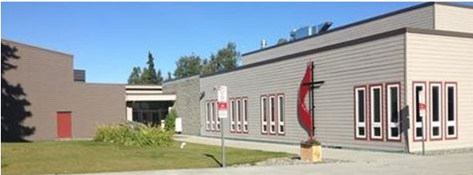
Image Description: Church building with flame & cross
St. John UMC in Anchorage, Alaska has an interpreting ministry and a disability ministry.

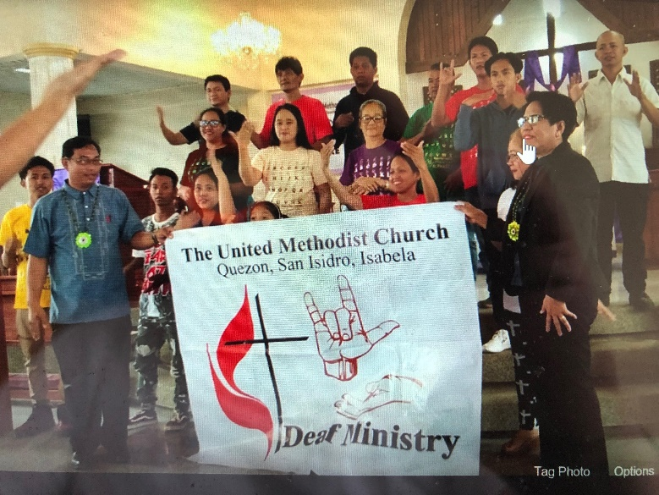
Image Description: A Deaf Filipino group holding a Deaf Ministry sign

This new Deaf Ministry in the Philippines were invited to perform songs in sign language.

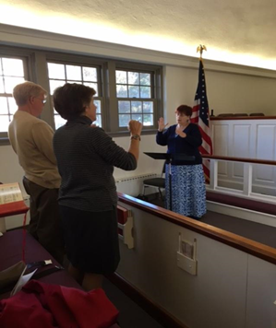
Image Description: 2 Deaf persons signing along with an interpreter in worship.
St. Paul's UMC in Odessa, DE has an interpreting ministry.

COMMUNICATION ACCESS SPOTLIGHT
Hearing loss is more common than we realize. According to the National Institute on Deafness and Other Communications Disorders (NIDCD), they report that men are almost twice as likely to experience hearing loss compared to women ages 20-69. Non-Hispanic white adults are more than likely than other racial/ethnic groups to have hearing loss. Non-Hispanic black adults have the lowest prevalence of hearing loss among the same age range. It's estimated that 28.8 million U.S. adults would benefit from hearing aids. These are just a few statistics; moreover, they show us the need to ensure there is communication access within church settings. To help churches to improve communication access, some are considering speech to text captioning apps. Live Transcribe and Sound Amplifier are two apps from Google. Other apps worth considering can be found here. It should be said that transcription software is not perfect, but it has come a long way.

DEAFBLIND MINISTRY SPOTLIGHT
Some Deafblind individuals enjoy going to Deafblind camp. Due to limited offerings, some Deafblind persons (and possibly their support service provider) may have to travel out of state to attend a camp. Some churches offer scholarships for individuals to attend camp. Why doesn't your church consider offering 1 or more scholarships so Deafblind persons can go to camp? It's considered a missional opportunity and it truly blesses the individual by allowing them fellowship with others who are also Deafblind. Some camps have a religious affiliation, while others do not. Either way, the Spirit of God is present. To consider offering a scholarship, check out this list of Deafblind camps. Maybe there's one in your state. A UMW group, a youth group, a choir, a missional outreach group, a Sunday School class, and other church-related groups can fundraise to offer a scholarship(s). Contact a camp near you and have the conversation. Plus, it's a wonderful way to connect with the Deafblind community!


Image Description: A guide with a blind person

DEAF LEADERSHIP STIPENDS AVAILABLE
One of the objectives of the Deaf and Hard of Hearing Ministries Committee is to support Deaf leaders within the denomination. During 2019, the Deaf and Hard of Hearing Ministries Committee is offering limited stipends for United Methodist churches to hire Deaf and hard of hearing persons as Deaf Ministry coordinators or some other related leadership role where. The stipend, a type of scholarship, can be for up to $3,000. Completing the grant application is the first step. A ministry plan is to be included with the grant application that shows how the Deaf or hard of hearing coordinator will either implement a new ministry or expand an existing ministry. The stipend is not for temporary or internship type positions, but for individuals who will be hired by the church for ministry or missional purposes. How the paid position will be continued beyond stipend is to be considered and included in the ministry plan (e.g. applying for grants, fundraisers, designated Sunday offering, reconfiguring the budget, etc.). The Deaf Ministry: Ministry Models for Expanding the Kingdom of God, 2nd Ed, includes ideas, especially within the Deaf Ministry Coordinator section, the Deaf Ministry Committee section, and the Disability Ministry Committee section of the book. The committee's coordinator, Rev. Leo Yates, is available for consultation by contacting him via email at leoyjr@gmail.com. Either Rev. Yates or a resource person can consult with a church leader or Staff-Parish Relations Committee (SPRC) about this opportunity.

Image Description: Ad: NOW HIRING - NEW OPPORTUNITIES

DEAF MINISTRY: BOOT CAMP OFFERED
Trinity United Methodist Church in McMurray, PA (Western PA Annual Conference) is hosting a Deaf Ministry: Boot Camp on Saturday, May 18th. This free seminar will orient individuals to the dynamics of a Deaf Ministry, how to implement a Deaf ministry, grant opportunities to support new ministries, and provide an introduction to American Sign Language. Please register at Eventbrite. Please contact Gail Brunson at trinitysigns530@gmail.com for any questions.
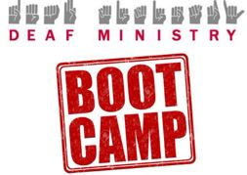
Image Description: Deaf Ministry BOOT CAMP

Copyright © * 2019 * Global Ministries Committee on Deaf and Hard of Hearing Ministries *, All rights reserved. Website: www.umdeaf.org. Email questions or comments to umdeaf@gmail.com
Mailing address:
General Board of Global Ministries
Attn: Sabrina Rodgers
458 Ponce De Leone Ave NE
Atlanta, GA 30308
Rev. Leo Yates, Jr.
Consultant, Global Ministries United Methodist Committee on Deaf and Hard of Hearing Ministries
Secretary, Baltimore-Washington Area Reconciling United Methodists
Associate Pastor, Magothy United Methodist Church of the Deaf

