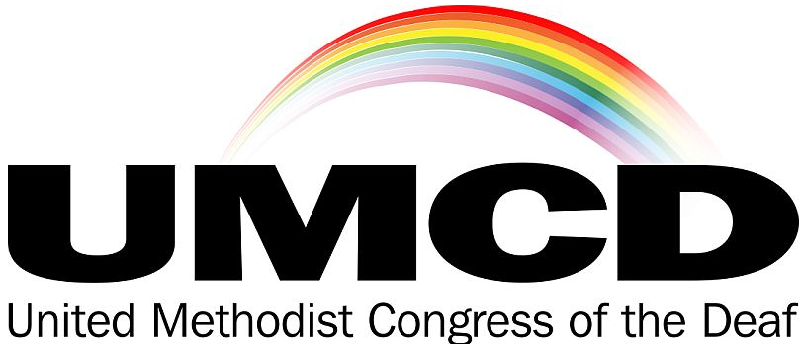

CONFERENCE NEWSLETTER
* * * 2023 SPECIAL EDITION * * *

November 3-5, 2023
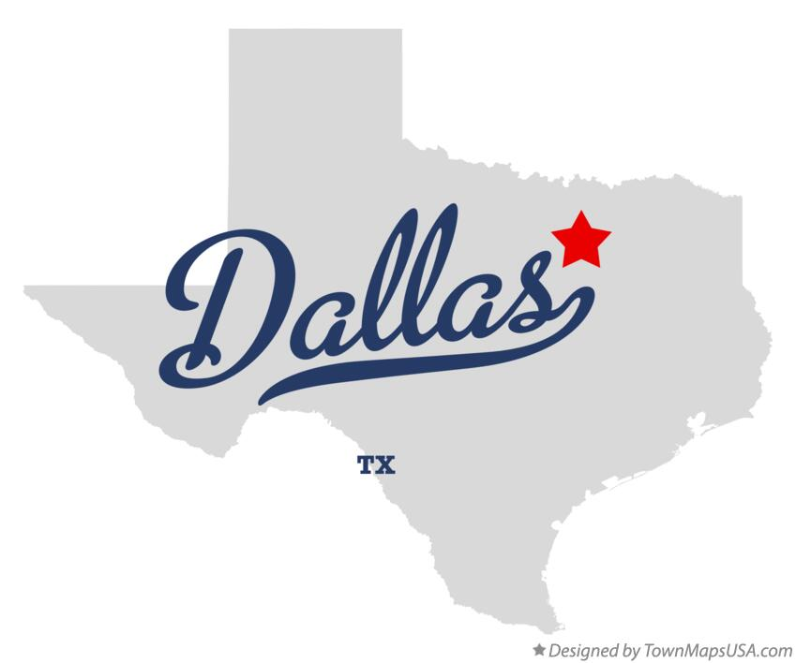
Deaf and hard of hearing United Methodists are heading to Dallas, Texas and Lovers Lane Deaf Ministry for the UMCD Leadership Conference, November 3-5, 2023 at the Walnut Hill campus. 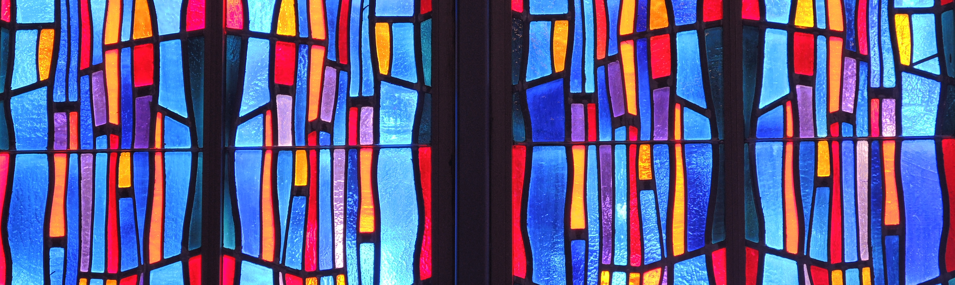

Conference Greetings from Bishop Peggy Johnson
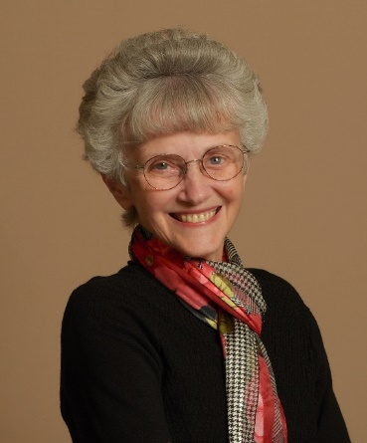
It is a joy to see that UMCD is once again meeting in person after a long pause during the season of COVID. I thank God for your leadership that has kept the light of mission and ministry shining bright, nonetheless. I hope you will learn many new things at this training event. Ministry continues to change as the Deaf and Hard of Hearing community changes through the years. I hope you will build community and relationships during this event. Find new ways to network with one another to increase your ministry reach. Finally, I hope you will have joy, the joy of the Lord, knowing that with God all things are possible. God is using you to cast a bright future for our ministry.

Conference Greetings from Rev. Tom Hudspeth
and Lovers Lane UMC
On behalf of the Deaf Ministry at Walnut Hill, A Ministry of Lovers Lane United Methodist Church, we are pleased to welcome you to Dallas, Texas. It has been a long five years since our last UMCD conference, which was held in Las Vegas, Nevada in 2018. We are welcoming participants from 12 states, the District of Columbia, and the country of Zimbabwe.
Here we will have: Certified Lay Servant training; workshops on church leadership, mission, spiritual gifts, understanding the Bible and interpreting Christian content in weddings, funerals, and sermons. Here our Deaf leaders will receive news about the 2024 General Conference in Charlotte, North Carolina and plans to build a Deaf school in Tanzania. Here new and dear friends will enjoy meals, fellowship, and worship. Here, we will offer a Deaf Gain vision for our beloved connection. We thank the Northeast Jurisdiction of the UMC, the United Methodist Congress of the Deaf Endowment Fund, the United Methodist Committee on Deaf and Hard of Hearing Ministries for generous scholarship support in making possible this special 2023 UMCD conference. Special thanks to co-pastors Andy & Melissa Nelms of Walnut Hill and church members who are offering hospitality for us at meals and workshops.
On Friday evening we will have a Keynote address by Rev. Dr. Kirk VanGilder of Gallaudet University, “The Ministry of All Believers.” On Saturday evening, the Rev. Dr. Gio Arroyo, General Secretary of the Commission on Religion and Race will address our Hasenstab and Moylan Awards on Excellence in Deaf Mission and Evangelism. This awards banquet will also introduce, for the first time, the Deaf Light awards on Deaf mission and evangelism. On All Saints Sunday morning, we will remember those Deaf saints who have died since our last UMCD conference. Thank you for sharing your gifts of prayers, presence, gifts, service and witness at this conference.
Grace and peace, Rev. Tom Hudspeth, Pastor of Care and Deaf Ministries and conference host pastor.

Conference Greetings from UMCD’s President
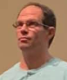
Mary Ann and I are delighted to gather with everyone at the UMCD conference. UMCD continues to work and encourage churches and ministries in The UMC to be welcoming & supportive of Deaf and hard of hearing people.
Billy Deters
.

News from UMCD

Special UMCD Board Meeting Scheduled
A special UMCD board meeting is scheduled for Thu, November 2 at 6pm at Walnut Hill UMC in Dallas. P.S.
Friday Note
On Friday, November 3, we ask our participants to help keep safe the Creative School pre-school children by staying in our UMCD designated areas and not going out the doors between 9am and 2pm

Leadership Trainings at the Conference
- Certified Lay Servant - Beginners
- Certified Lay Servant – Advanced
- Spiritual Gifts for Leadership
- UMC Leadership 101
- Pastoral Care 101
- Cultural Immersion: Making Tamales
- Interpreting Workshops
- Demystifying the Bible

News from the Deaf & Hard of Hearing Ministries Committee
The DHM committee is delighted to share they have supported Deaf ministries world-wide. Grant recipients for 2023 include:
* $1800 - Glendale UMC in Nashville, TN
* $5,000 - Kabwe Deaf UMC in Zambia
* $5,000 – Yatosha Deaf Project in Tanzania
* $3,000 – Fizi District UMC in East Congo AC
$14,000 in micro-grants for churches world-wide to celebrate Deaf Awareness Month.
$7,000 – for the UMCD Leadership Conference.

Africa Mission Trip
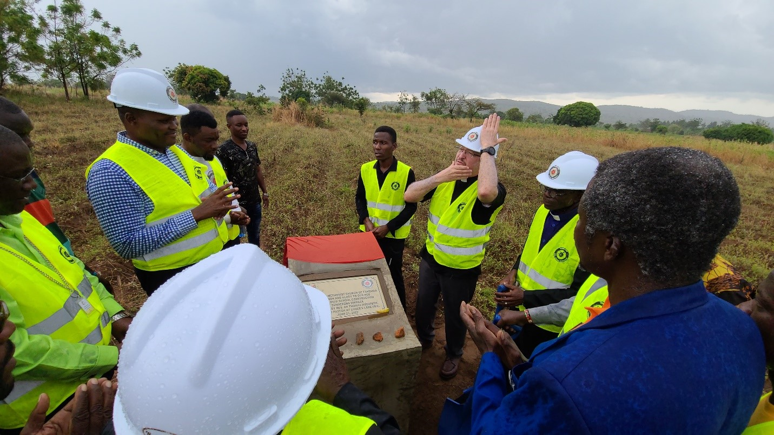
Rev. Dr. Tom Hudspeth, Rev. Dr. Kirk VanGilder and Candas Barnes flew to Africa this past June for meetings, visiting mission sites, to learn about projects, and offer support to our Deaf African United Methodists. The countries visited included Zimbabwe and Tanzania.

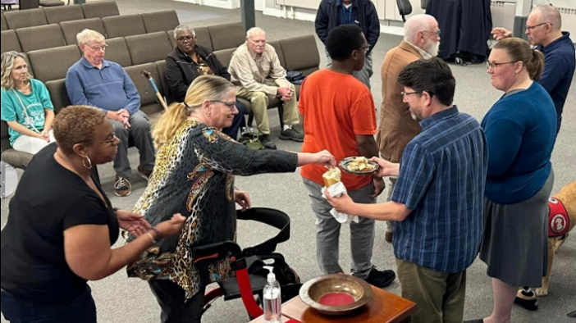
Deaf Ministries Gathering
September 30th was a Deaf Ministries gathering for churches in the Baltimore-Washington Conference and the Pen-Del Conference, meeting at Glen Burnie UMC. Celebrating Deaf Awareness Month, participants worshiped, networked, did team building exercises, and had Communion together.

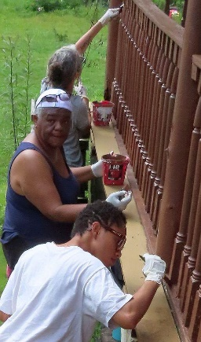
Deaf Missions in the US
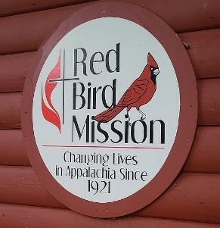
A group of Deaf and hearing United Methodists and extended friends, including the Evangelical Lutheran Deaf churches, visited the eastern part of Appalachia in Kentucky. The trip was August 6-11. The team rehabbed homes. The trip was sponsored by ELM, the ecumenical organization of Episcopal, Evangelical Lutheran & UMC Deaf ministries.
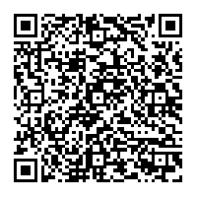
Scan this code to read the full articles about Africa and Red Bird

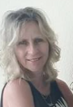
News from the Northeast Jurisdiction
We are delighted to share that there were a number of Deaf ministries in the NEJ that participated in Deaf Awareness Month (in September). Some even received grants. The Deaf Community has important place in society and it’s important we share awareness. I’m so glad to see NEJ is well-represented at the UMCD Conference!
President Karen Miller

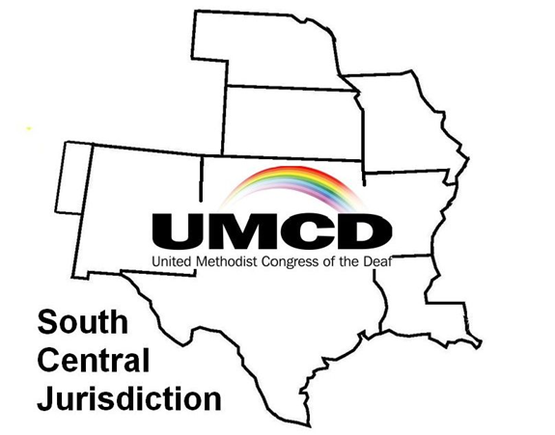
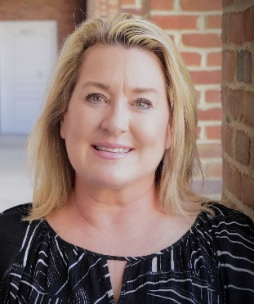
News from the South Central Jurisdiction
Welcome to the South Central Jurisdiction. I am Mary Kay Hudspeth of Dallas, Texas where I serve as President of SCJ-UMCD, representing eight states: Louisiana, Texas, New Mexico, Nebraska, Oklahoma, Kansas, Missouri, and Arkansas. Our last SCJ meeting was in July 2019 hosted by the First United Methodist Church in Huntsville, Texas. We have been inactive due to covid19 pandemic for five years. Our treasurer is Karen Harrell, of Tulsa, Oklahoma. Our other officers have been inactive. We are looking forward to the United Methodist Congress of the Deaf meeting at Walnut Hill Church, A Ministry of Lovers Lane UMC in Dallas Texas. Pastor Tom Hudspeth is organizing hosting this special event of UMCD with support of UMCD members via zoom meetings, video phones, emails, and few volunteers of Walnut Hill Church. We have recently added new members to SCJ UMCD from Walnut Hill: Naomi Rapp, Susan Judd, Anu Adeola, Brenda and Joel Rodriguez. We are recruiting more members. Our dues are $20 for 2 years (same as UMCD). Several of our SCJ UMCD members also participated in the 2019 and 2023 Red Bird Mission Work Camp with other Deaf from UMCD. Praying it continues to grow and strengthen SCJ-UMCD by reaching out more Deaf participants throughout 8 states. Shalom to you, my friends.

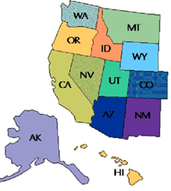
News from the Western Jurisdiction
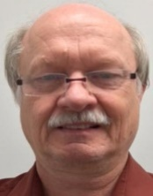
There are a number of interpreting ministries in the Western Jurisdiction (WJ). The interpreting ministries are in Washington State, including Manito UMC in Spokane, which also has a hearing loop system; Kona UMC in Hawai’I; California, and Alaska (Anchorage). We have shared information about DHM grant opportunities and encouraged churches to celebrate Deaf Awareness Month. Rev. Bob Walker, who died in 2020, was a former DHM member who lived in the WJ is still sorely missed for his activism.
Bryan Branson, President of the UM-DHM and Western Jurisdiction President of UMCD.

News from the Treasurer of UMCD!
We are glad to partner with UMCD. Your dues and additional gifts to UMCD help conferences such as this happen. For example, many scholarships for this UMCD Leadership Conference in Dallas are funded in part from our Endowment Fund: $4000 worth of scholarships!
UMCD also gave scholarships totaling $1354.28 for travel expenses for Martin Sichone in Kabwe, Zambia (Africa). Martin (Deaf) is starting a Deaf UMC and wants to study at Africa University in Zimbabwe. UMCD also helps fund interpreter/closed caption fees for conferences, travel stipends for officers, Red Bird Mission and miscellaneous expenses such as the trophies for Hasenstab, Moylan and Deaf Light awards.
Dues are $20/year.
At the time of this writing, here is a summary of UMCD Funds:
$1786.13—checking
$26,727.00—Stock Market
$ 5,709.86—Money Market
$3560.88-- Designated Funds (UMCD holding in its account, but not available for UMCD use)
NCJ-UMCD $1500.88
Acquisition of property for Deaf meeting $2060.00
(place of the Kaaga Synod of Methodist Church of Kenya (includes $60 for wire transfer)
Endowment balance (July 31, 2023), $36,437.
Linda Ford
UMCD Treasurer/Endowment Fund Chair
Deaf
Africa’s Extraordinary
Events
–
June 2023

(Blessing the Yatosha Deaf School site, Sengerema, Tanzania. June 21, 2023.
Rev. Tom Hudspeth, center, is signing and saying “Baba Mungu” (Swahili for, “God our Father”)
in Tanzanian Sign Language.)

By Rev. Dr. Tom Hudspeth, Consultant for the UM-DHM

I usually do not think of rain as being an extraordinary event, but when rain, time, place, and particular people converged at a cornfield within sight of Tanzania’s Lake Victoria on the first day of summer, rain delivered an extraordinary Divine sign and blessing. During the month of June 2023, this cornfield rainfall came to highlight a series of extraordinary events in a two-country journey to Deaf Zimbabwe and Tanzania.

On June 4, 2023, I departed Dallas, Texas for Dulles airport near Washington, D.C., where I would be joined the next day by Rev. Dr. Kirk Van Gilder and our sign language interpreter, Candas Barnes – both from Gallaudet University, the world’s only liberal arts university of the Deaf. Our journey from Dulles would take us to Africa University in Mutare, Zimbabwe, where we would witness Collins Prempeh, the first Deaf student of Theology, graduate from AU on June 10. Collins was a four-year scholarship recipient from SEEDS (Serving and Educating Exceptional Deaf Students) a Deaf ministry of Lovers Lane UMC, Dallas, as well as a solidarity grant scholarship recipient from our UM-DHM committee.

(l to r: Tom Hudspeth, Kirk Van Gilder, Candas Barnes)

While in Zimbabwe, we would meet with the Vice Chancellor of AU, Rev. Dr. Peter Mageto, and other Deaf ministries in Zimbabwe. Joining us was a Zambian Deaf teacher of the Deaf, Martin Sichone, who on December 11, 2022, with Rev. Daiman Mainsa, the District Superintendent of Lusaka, had opened the first Deaf UMC ministry in Zambia with a grant from our UM-DHM committee. (See this article from Africa University).

(Collins Prempeh, 2023 B.A. Graduate in Theology, Africa University)

Living adjacent to Zimbabwe, Martin came at my invitation as a prospective Deaf student at AU, to meet Collins, visit the campus and professors. We would also meet Collins’ sign language interpreter, Tonderayi “Tonde” Makaya, who we would honor as Africa University’s first full time sign language interpreter (A user of Zim Sign, Tonde had to learn Ghanaian Sign Language, Collin's first language. Tonde had also received a UM-DHM scholarship for research on Deaf education in Zimbabwe).

While at Africa University, we introduced Collins and Martin to Rev. Dr. Emmanuel Sinzohagera, the Bishop’s legal representative of the Burundi UMC Annual Conference; Bishop Eben Nhwatiwa of the Zimbabwe East Conference; James Salley, CEO of Africa University, Tennessee; Rev. Tendai Makono, Mutare District Superintendent; and Bishop Mande Muyombo of the North Katanga, Tanzania and Tanganyika Conferences and chair of AU board of directors. Ideas for expanding Deaf ministry in Burundi, Zambia, Zimbabwe, and Ghana were exchanged. Collins and Martin, both Deaf men, husbands, and new fathers involved with Deaf ministry, shared joys, and challenges of being Deaf among hearing people. On June 11, we worshipped at Hilltop UMC in Mutare, also a UM-DHM grant recipient years ago, thanking them for providing a Deaf witness and place that mentored Tonderayi, who in turn, became Collins' advocate and access to Africa University. Zimbabwe).

(Tonderayi Makaya, interpreter, Hilltop UMC, Mutare, Zimbabwe)

(Tom and Collins review for an interview with Deaf TV Zimbabwe
at the home of Lovemore Chidemo and Agness Chimbinda, producers, Harare, Zimbabwe.
Click here to see link to YouTube interview.)

Two days after Collins’ graduation from among AU’s highest graduating class of 954 students, he, Martin, and I traveled to Tanzania for eleven days to meet with leaders of the Yatosha (Swahili for “enough”) Deaf project (another UM-DHM grant recipient). There we also met Rev. Mutawle Ntambo, the Bishop’s representative to the Tanzania Annual Conference, Rev. Isaka Ibrahim the District Superintendent of Dar Es Salaam, and Deaf leaders, including those at the Tanzania Sign Language Bible Translation project and the Immanuel Deaf Church. Martin, Collins, and I joined with Pastor Isaya Mwita Matiku, the Deaf pastor for Dar Es Salaam’s First UMC, to lead Deaf workshops on “Seven Steps on How to Know God” for groups in Dar Es Salaam and at Mwanza, near Lake Victoria.

(Collins, left, welcomed by Simon Ngigi,
Deaf Consultant for the Tanzania Sign Language Bible Translation Project, Dar Es Salaam)

(l to r: Collins Prempeh, Tom Hudspeth, Martin Sichone)

(Tom Hudspeth (l) gives an illustration of being connected to Jesus the Vine,
while Pastor Isaya and Collins Prempeh (right) look on.
Sebring-Mwanza Mission, Tanzania)

Following the two-day workshop in Dar Es Salaam, Pastor Isaya assisted me in remembering and administering baptism vows for the first Deaf members of FUMC, Dar Es Salaam: Sianga Richard, Siana Benedicta, Mapple Xahaya, Hiliali Peter, and Consolata Mhagama. We, along with a hard of hearing Muslim ASL interpreter, stood knee-deep in waters from the Indian Ocean near the Nyerere Bridge, as I used Tanzanian Sign Language for “Father, Son and Holy Spirit.” The next day, on June 18, we worshipped at First UMC Dar Es Salaam, as these newly baptized Deaf received communion. As Collins signed his sermon, mostly in ASL mixed with Ghanaian Sign, I voiced his sermon in English, which was translated into Swahili by Nyasinde Pablo, the director of Yatosha, and from Swahili, the sermon translated into Tanzanian Sign Language. This four-language sermon was the first time a Deaf person had preached in that church. Collins’ testimony of his mother’s traumatizing attempts and others to heal his deafness awakened the congregation’s sensitivity to not fix Deaf people, but to accept Deaf people and their language of sign as a gift to the community and Church.

(The baptism of Consolata Mhagama, near the Nyerere Bridge, Dar Es Salaam, Tanzania,
June 17, 2023
Left to right standing: Rev. Tom Hudspeth, Habibu Mlope, Pastor Isaya Matiku)

After a three-hour flight from Dar Es Salaam, passing a cloud wreathed Mount Kilimanjaro, we arrived at a warm Yatosha team welcome in Mwanza, and the clear air of Lake Victoria’s shores. After a visit at Wesley College and with Rev. Boniface Wanyama, Head of Theology, the divine date with the rainfall in the cornfield occurred on the first day of summer, June 21. In our three-car entourage were dignitaries from Wesley College, the Lay Leader and Trustees of the Tanzania Annual Conference, Rev. Denis Simon the District Superintendent of Mwanza, local Deaf church leaders, Yatosha Deaf Ministry leaders, and our trio of Martin, Collins, and me. The object of our travel would be the future site of Yatosha Deaf School, where 300 primary students will reside to learn Tanzanian Sign Language and English.

Crossing an inlet along Lake Victoria, on a ferry jammed with vendors, workers, motorcycles, buses, and cars, we jostled off the ferry’s gray-steel ramp, surging among a riot of commotion past corrugated metal topped awnings that lined the road. As we drank a soda among skinny wooden poles propping one such awning, one of the Immanuel Deaf church pastors, Benedict, signed to me, “There’s rain forecasted where we’re going,” pointing to his cell phone. Unconvinced, I looked up and saw only a couple of clouds. I signed and spoke, “I came prepared, I brought my rain jacket.” Overhearing me, Rev. Boniface interjected, “In Africa, rain is a blessing!” To which I replied, “Then I won’t wear my jacket! Let me be blessed!”

Thirty or so minutes of dirt roads led us through rice fields, farms, livestock, hamlets, and eventually a narrow, rutted path fronting a mudbrick home. The skies above grew darker as gray clouds converged. I copied the quick exits from our cars, donning a bright yellow vest and hard hat, as were the others. Raindrops, thick and heavy, pattered here and there. I trailed the quick moving line of suited neon-yellow vests, past the mud-brick home and clothesline. In the distance was Lake Victoria. The path bent between trees and cornfield. A few children and local village leaders joined in the single-file parade. Soon we gathered around at the edge of a corn field, at a waist-high concrete square block, its angled top draped with a rain-soaked red cloth. I was invited to remove the cloth, which revealed a brass-colored plaque, with its top corners adorned with the United Methodist Cross and Flame and logo of the United Methodist Committee on Deaf and Hard of Hearing Ministries. Stenciled in black, were these words:
“The United Methodist Church of Tanzania for Honor and Glory to Our God, Yatosha Deaf School Construction at Sengerema, Mwanza. Dedicated by Rev. Dr. Thomas Hudspeth, Associate Pastor at Lovers Lane UMC, June 21, 2023.”

As I prayed to bless the land for the school, rain fell thick and heavy, clinging clothes to skin. I ended our prayer with singing and signing “Praise God from whom all blessings flow…” The dignitaries responded with a Swahili version of the Doxology sung to the tune of "Holy, Holy, Holy, Lord God Almighty." As we walked along the 6-½ acre property line, back to our cars, the rain lessened, and trailed off.

A few days later, I and all who had been blessed by that rainfall would be returned to our homes in Ghana, Zambia, Tanzania, and Texas. Lodged in my conversations with God, was the knowledge of that rainfall breaking a two-month dry season spell. I had not asked nor sought a sign during the three weeks I was in Africa. I had not felt rain in Zimbabwe nor in Tanzania, except for in that cornfield where a Deaf school will emerge. I think God gave us the rainfall as something to remember and marvel. To bless us when the way to building a Deaf school becomes dry and difficult, and to see rain as God’s sign:
“I bless the Deaf, and all who will build and come to this school.”

Our Deaf ministry in the United Methodist Church is in a season of new blessings emerging in Africa, blessings which invite us all to respond with the grace God has given us to pray, gift, serve and witness to Christ’s love that is enough for all.

Zimbabwe Report
by Rev. Dr. Kirk VanGilder

When Tom, Collins, and Martin departed for Tanzania, Kirk and Candas remained in the Mutare area to connect with our long-term partners in Deaf ministry and outreach with the Nzeve Deaf Centre and Hilltop United Methodist Church. The Nzeve Deaf Center (https://nzeve.org.zw/) is celebrating its 23rd year in operation as a hub for early intervention, preschool education, Deaf youth vocational training, and community outreach and education for Deaf people in the Mutare area in the Eastern Highlands of Zimbabwe. The founding director, Ms. Libby Foster, has retired and moved back to England with her husband, the new director, Karina Martin, is an experienced leader in non-profit organizations from Poland who is married to a Zimbabwean. She is busy learning Zimbabwean Sign Language, the skills and challenges of Deaf people in Mutare, coming up with innovative new projects to achieve the goals the Deaf community establishes.

Nzeve does a great deal of early contact intervention with parents of Deaf children helping them understand their child is capable of learning and achieving their dreams, then resourcing the family with a place to learn about deafness, Zimbabwean Sign Language, and how to welcome and nurture their Deaf child. They also have pre-school classes that enrich Deaf children’s learning with Deaf teachers and hearing teachers using Zimbabwean Sign Language. Nzeve is also home to the Sanganai Work Project where Deaf youth learn valuable trade skills, home and life management skills, and important public health information. Clothes making, farming, and woodworking are the main skills taught but these skills support other projects too. One of the new projects started with funds given by individuals and Magothy UMC of the Deaf in Pasadena, MD is a project to train Deaf women how to sew affordable and reusable sanitary pads. Many Deaf women in Zimbabwe lack the income to afford expensive paper based sanitary pads for menstruation. Therefore, they sometimes must choose between food and pads, or travel to work to get paid or pads. The alternative is often unsanitary use of rags that leads to infections and other health problems. The new work project has brought in women from Harare who do community-based women’s support work to discuss the issues of hygiene and train women how to make affordable and reusable sanitary pads and then train other Deaf women to improve their health and independence.

(Sanganai Work Project, Nzeve Center for the Deaf, Zimbabwe.
On the right is Raymond Makuwaza, a Hilltop UMC sign language interpreter)

We also facilitated two workshops for the Nzeve staff. One that focused on report writing and becoming familiar with Microsoft Office programs on laptops the Centre staff have from an overseas grant. Deaf and hearing staff both were brimming with questions and excitement to learn new skills and make their reports and presentations more professional. Candas also facilitated a conversation with area interpreters and aspiring interpreters learning Zimbabwean Sign Language on the role and function of interpreters for Deaf people.

(A poster at Nzeve Center for the Deaf, Mutare, Zimbabwe)

Candas and Kirk also attended Hilltop UMC and reconnected with the vibrant Deaf ministry there. Around 45 Deaf people were in attendance to celebrate and recognize Collins Prempeh’s graduation in Sunday Worship. Hilltop UMC remains a vital part of the Deaf community’s spiritual life.

(Kirk, at center-left, sharing a joyful moment at Chin’ando Prayer Mountain at Old Mutare, Zimbabwe,
as the Women’s Fellowship of Hilltop UMC, sing a song for his 50th birthday, June 11, 2023)

Note

All expenses for this five-person Deaf team that served in two countries were paid by connectional giving, administered by the General Board of Global Ministries through the United Methodist Committee on Deaf and Hard of Hearing Ministries and the Advance Special on Deaf and Hard of Hearing Ministries, as well as grants from SEEDS (a 501(C)3 ministry of Lovers Lane UMC, Dallas, Texas) the United Methodist Congress of the Deaf and family donations).

To give to the Advance Special on Deaf and Hard-of-Hearing Ministries and to donate toward the Yatosha Deaf School project, please go to https://umcmission.org/advance-project/982562/
Please contact Rev. Dr. Tom Hudspeth at thudspeth@llumc.org when identifying a gift for the Yatosha Deaf School project through the Advance Special.

For more information and to apply for a UM-DHM grant or scholarship, please go to our website to download a form: https://www.umdeaf.org/fund.html.

(Artist’s rendering of the Yatosha Deaf School project, by Nyaside “Pablo” Mwamba Rashid).

Deaf Team to Red Bird Mission

By Carol Stevens

How do you develop Christian relationships, spiritual growth and have lots of fun? Go on a mission trip!

From August 6 to 11, 2023, 19 people went to Red Bird Mission in the mountains of Appalachia in eastern Kentucky to meet the people and help them to rehab their houses. The team consisted of 11 Deaf members and 8 hearing members representing the United Methodist and Evangelical Lutheran Deaf churches. The team arrived on Sunday from Texas, Oklahoma, Florida, Maryland, Delaware, Virginia and Washington, D.C. excited to see each other and settle into the dorms.

Red Bird Mission and Clinic have been in ministry since 1921. The needs remain critical, especially since the closing of the mines. Poverty, lack of jobs, poor housing and the rugged mountains cause many challenges. However, the people are kind and gracious and very resourceful and clever. In addition to a clinic and a school, Red Bird hosts team from churches to come and repair and rehab homes.

Every day was filled with devotions, and meeting and working with the homeowners to repair their houses. The teams rehabbed bathrooms and painted and sanded a ramp and worked in the store where donations are prepared and resold to residents of the mountains. At night we had wild games of UNO with 16 people gathered around one table laughing and screaming. On the final night we were all touched by the Deaf-led closing worship and Holy Communion.

This mission was sponsored by ELM, the ecumenical organization of Episcopal, Evangelical Lutheran and United Methodist Deaf ministries. We are looking forward to our next Red Bird mission trip in the summer of 2025. Join us!

If you want an easy -to-do mission trip, check Red Bird’s web site.

